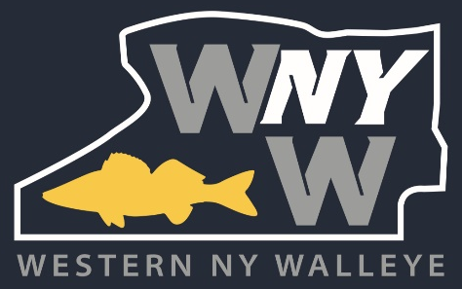

January 1, 2026

To whom it may concern:

Western NY Walleye is a new organization to the sport of walleye fishing that was established as a not-for-profit 501c7 in March of 2024. Our objective is to further the sport of walleye fishing while providing a positive impression to the community and positive environment for the next generation to learn more about the sport. In addition to positively representing recreational fisherwomen and men, we will strive to incorporate these goals in everything we do.

CLUB GOALS:

- To honor our walleye fishing heritage by sharing walleye fishing.
- To build camaraderie and friendships within the membership.
- To encourage conservation and respectful use of recreational and natural resources.
- To represent anglers positively to the community.
- To work with the fishing industry, promoting and protecting our sport for the future.
- To increase access to the lake.
- To prevent the evolution of the club into a business.

We are humbly requesting your support for the numerous events that we will be hosting in 2026. By sponsoring our events you will be supporting our organization as we grow with the goals outlined above as our objective. Our belief is that your participation will offer an opportunity for a mutually beneficial relationship moving forward.
Thank you for considering our request and we look forward to hearing from you.
Sincerely,
Western NY Walleye Board of Directors

P.O. Box 352, Athol Springs, NY 14010

